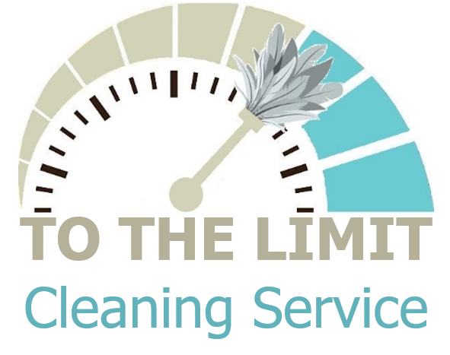

**Professional Cleaning Service your Home and Office Needs!**



**Our Philosophy!**

**To The Limit Cleaning Service is founded on the philosophy of precision, professionalism, and personalized care. We believe in meeting expectations through meticulous attention to detail, unwavering commitment to quality, and a tailored approach that ensures every space we clean reflects our dedication to creating pristine and welcoming environments.**

**Call to schedule a consultation**

**704-989-6959**

**Licensed and Insured**



**Have you experienced the following?**

**Not the clean I thought I would get**

**Breaking things or items missing**

**Not being pet friendly**

**Unreliable**

**Different service providers**

**Inconsistent results**

**No communication with service provider**

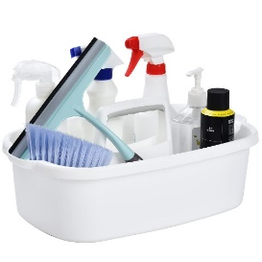

To The Limit Cleaning Service ensures an unparalleled standard of cleanliness by employing a meticulous and detail-oriented approach, leaving your space impeccably cleaned. Our professional team combines efficiency with precision, delivering a superior cleaning service tailored to meet your needs

**We offer the price that best fits your needs!**

We conduct thorough pre-cleaning walkthroughs, engaging in detailed discussions to understand your expectations and unique requirements. Subsequently, we craft a customized cost plan, ensuring mutual agreement and satisfaction for both parties.

|  |
| --- |
| **General Cleaning** |
| **Dust lamps, light fixtures, and ceiling fans** |
| **Dust window ledges and blinds** |
| **Dust furniture, shelves, and décor** |
| **Vacuum upholstered furniture** |
| **Dust baseboards** |
| **Wipe down doors and doorframes** |
| **Clean out corners for cobwebs** |
| **Vacuum all floors, carpets, rugs, and stairs** |
| **Mop hard floors** |
| **Clean glass surfaces** |
| **Straighten pillows and linens** |
| **Empty and replace bag in wastebasket** |

**“We guarantee our service or you don't pay!”**